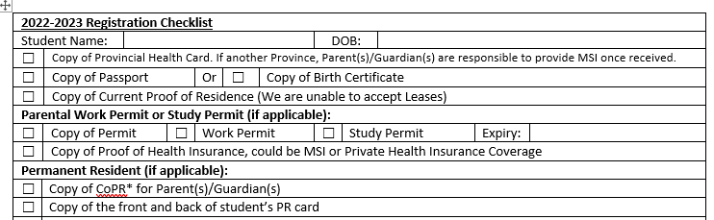

Please complete 2022-2023 Registration form located on www.hrce.ca.
https://www.hrce.ca/node/39933 (Word & Excel versions for downloading)
Please email the completed registration form as well as the above required paperwork to our school email address:
sunnyside@hrce.ca
You will receive email confirmation once all required paperwork has been collected.
Thank you.

